Part of: Conditional Logic:
- To apply logical conditions on existing E-Commerce data and generate meaningful labels using SQL CASE expressions without modifying the table structure.

Sub-Task A: Product Price Category

- Task Description:
Classify products based on their price.
- Logic Applied:
- Price < ₹10,000 → Budget
- Otherwise → Premium
SQL Query:
SELECT product_name, CASE WHEN price < 10000 THEN 'Budget' ELSE 'Premium' END AS price_categoryFROM products;
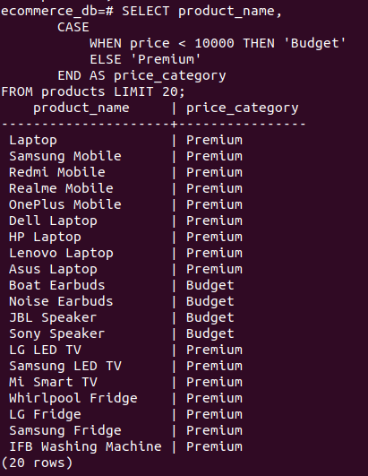

- Explanation:
This query checks product stock levels and assigns a readable status to indicate availability.

Sub-Task C: Order Status Based on Date

- Task Description:
Classify orders based on their order date.
- Logic Applied:
- Orders before 2020 → Old Order
- Otherwise → Recent Order
SQL Query:
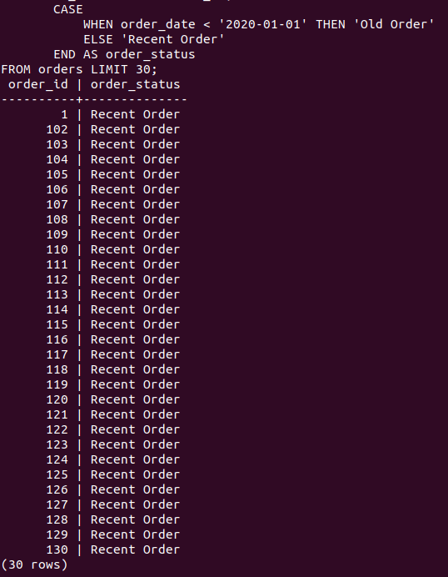
SELECT order_id,CASE WHEN order_date < '2020-01-01' THEN 'Old Order' ELSE 'Recent Order'END AS order_status FROM orders;

- Explanation:
This query applies logical conditions on order dates to classify orders based on their age.

Conclusion:
Logical transformation allows converting raw database values into meaningful business information. Using the CASE statement improves data readability and supports better decision-making in E-Commerce systems.

